Multi-Developer OpenCMS Development Environment With SVN Integration

🏢 SERVER-SIDE SETUP (SVN + OpenCMS Hosting)
🔹 1. Install SVN Server
Recommended OS: Ubuntu Server / CentOS / Debian

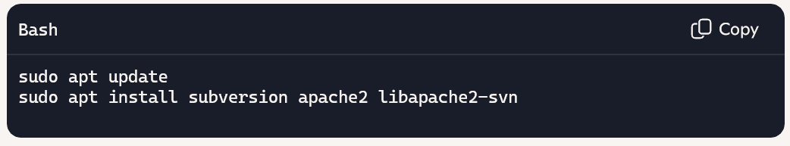
🔹 2. Create SVN Repository
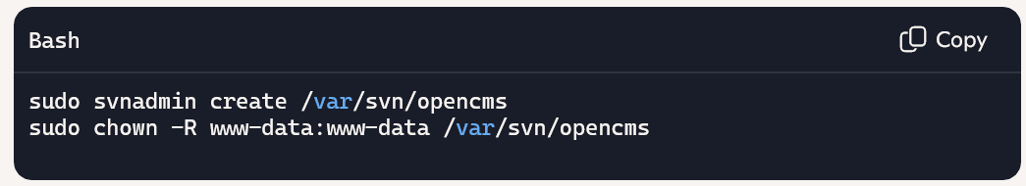
🔹 3. Configure Apache for SVN Access
Edit /etc/apache2/mods-enabled/dav_svn.conf:

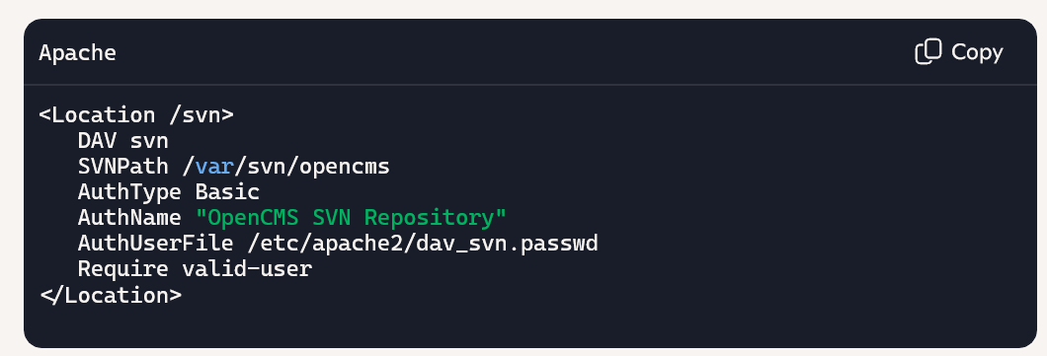
Create user credentials:
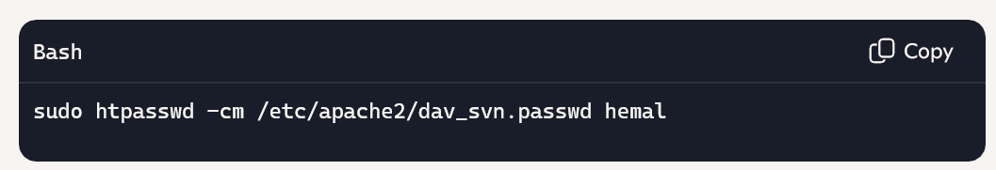Restart Apache:
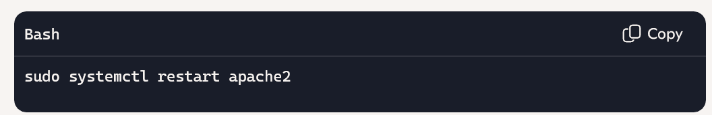
Access SVN at:
http://your-server-ip/svn/opencms

🔹 4. Install OpenCMS on Server
- Install Java JDK 11 or 17
- Install Apache Tomcat 9.x
- Install MariaDB or MySQL
- Download opencms.war and deploy to Tomcat
- Run setup wizard: http://your-server-ip:8080/opencms/setup/
- Create a dev database: opencms_dev

📁 SVN Integration for Code & Modules
Item | Versioned in SVN?
Custom modules (/modules) | ✅ Yes
Templates (JSP, CSS, JS) | ✅ Yes
Configuration files (opencms-importexport.xml, etc.) | ✅ Yes
Content (pages, assets) | ❌ No (handled via export/import)
🔧 SVN Setup
- Create SVN repo: https://svn.example.com/opencms-dev
- Checkout working copy into your IDE
- Link /modules/your-module-name to SVN
- Use build.gradle or ant for module packaging (optional)

💻 CLIENT-SIDE SETUP (Developer Laptops)
🔹 1. Install Required Tools
Tool | Purpose
Java JDK | Compile modules
IDE (Eclipse/IntelliJ) | Code editing
SVN Client (TortoiseSVN, SmartSVN, or CLI) | Version control
Gradle or Ant | Build automation
Tomcat (local) | Local testing
MariaDB/MySQL | Local DB (optional)

🔹 2. Checkout SVN Repository

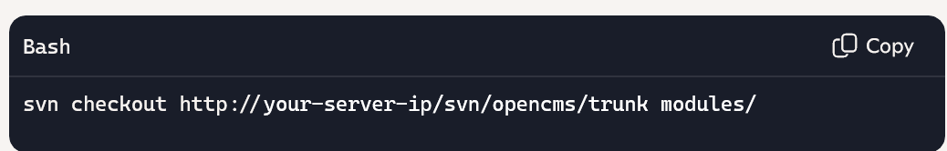
Each developer works in their own working copy of /modules/your-module-name.

🔹 3. Configure IDE for OpenCMS Module Development
Eclipse (Gradle-based)
- Create new Gradle project
- Add build.gradle:
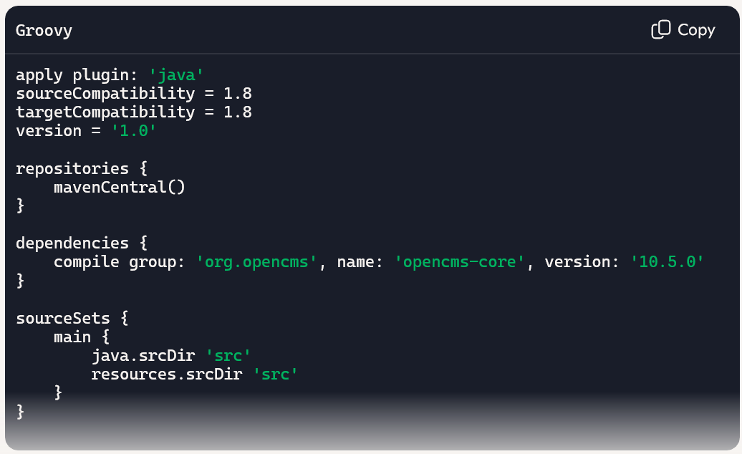
- Refresh Gradle dependencies
- Place Java code in src/org/yourmodule/

🔹 4. Local Testing
- Deploy OpenCMS locally via Tomcat
- Copy module folder to /webapps/opencms/WEB-INF/modules/
- Use OpenCMS workplace to preview and test

🔁 COLLABORATION WORKFLOW
🔹 Daily Developer Workflow
Step | Action
1 | Checkout/update SVN repo
2 | Develop module locally
3 | Export module via OpenCMS workplace
4 | Test locally
5 | Commit changes to SVN with structured message
🔹 SVN Commit Template
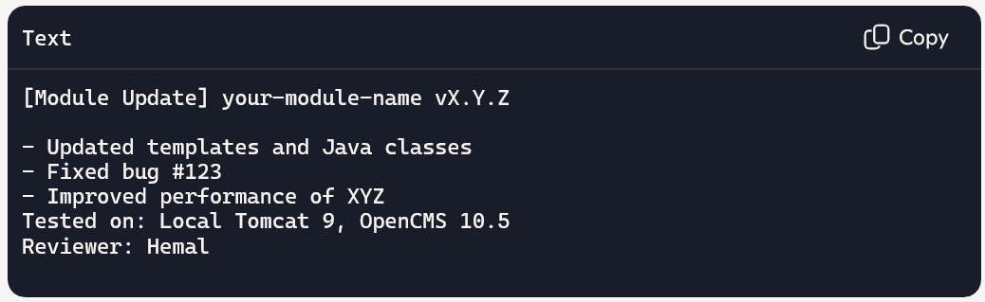

🚀 MOVING TO QA & PRODUCTION
🔹 QA Server
- Checkout latest SVN revision
- Import module via OpenCMS workplace
- Import content via .zip (if needed)
- Run QA checklist
🔹 Production Server
- Tag stable SVN revision
- Checkout tagged version
- Import module and content
- Perform smoke tests

